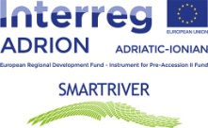

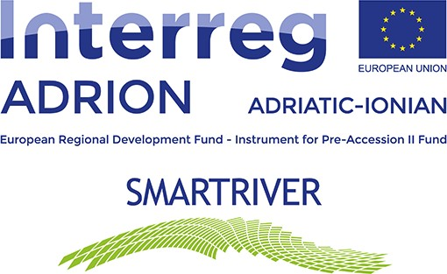

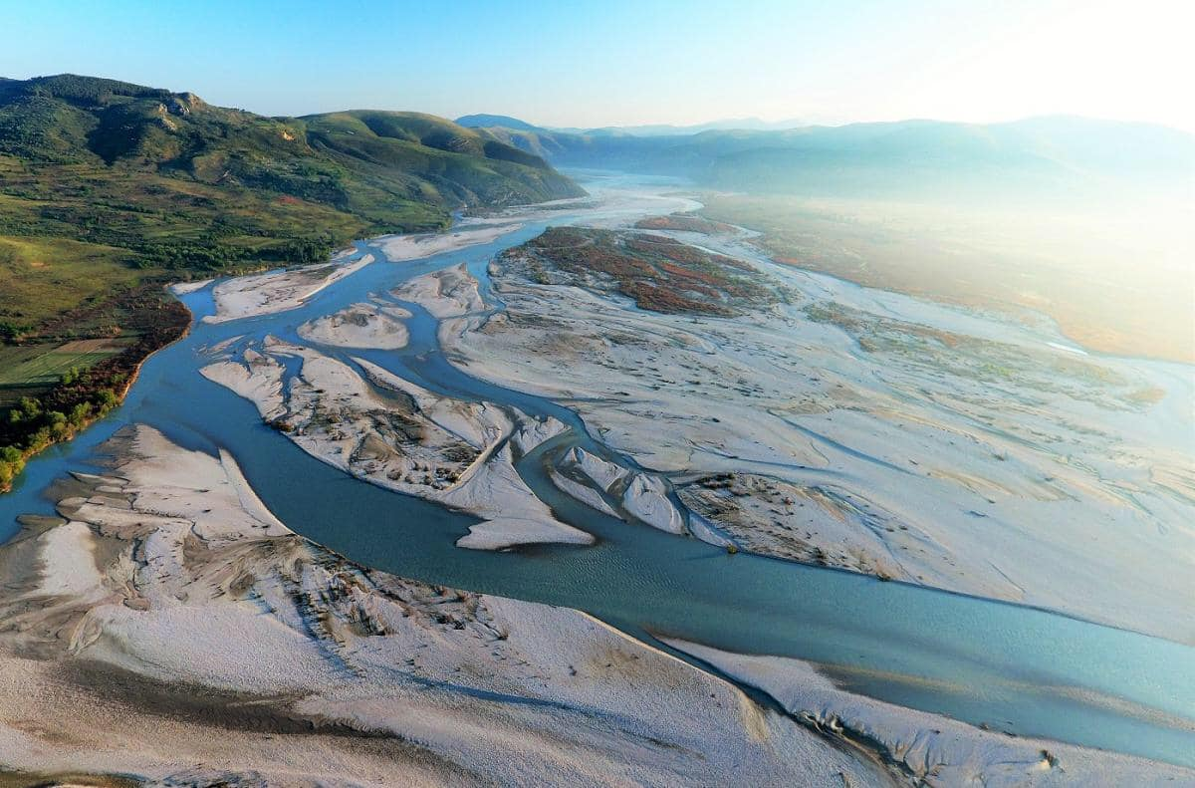

Reports on cross-sectoral fertilization workshop supporting risk and vulnerability assessment and FRRPs definition

21/02/2023

D.T2.4.1. Reports on cross-sectoral fertilization workshops
Within the INTERREG V-B Adriatic-Ionian ADRION Program 2014-2020, Change-AZHR in cooperation with the National Agency of Natural Resources (AKBN), the Ministry of Energy and Industry, the Local Government Units of Vlore, Selenice, Novosele and Permet, a workshop with the participation of local actors and community groups.
The sustainable development of rivers requires the management of a series of overlapping and closely related systems, which change in time (day, month, year), in space (rivers often exceed city or state borders), in context global (phenomena such as climate change or the integration of European laws, conventions and regulations in the context of a country like Albania) and in the broad horizontal impact (environmental, social, economic impact). The overlap of all these systems with the totality of the elements that characterizes each of them in a management plan for the long-term sustainable development of a river, especially in the case of Albania, has been developed only in partial dimensions.
The Vjosa River has been the subject of quite a few controversies in recent years, due to numerous floods in its valleys and the construction of HPPs, and numerous local and foreign initiatives to return it to the status of a national park, in order to be able to protect against such constant threats. Bringing to attention the importance of this river and not only in Albania, as well as the continuous attempts to incorporate the concepts of sustainable development of water resources, this program aimed to measure the sustainability of the Vjosa River, through the design of a methodology which simultaneously assessed the three main dimensions of sustainability, economic, environmental and social.
The inclusion of the Vjosa River in this program was tried to be comprehensive in the selection of indicators of the three dimensions of sustainability, including a total of 26 indicators of the three basins. The environmental indicator included maximum annual flows, maximum perennial flows, maximum flood discharge capacity, surface water and groundwater quality, sediment load and transport, number of flora and fauna species, number of fish species, number of species endangered, as well as land use along the river. On the other hand, the social indicator included floods, with data such as days of flooding, flooded surface, water use, with a special emphasis on the use of water for agriculture, the percentage of polluted water treated, as well as indicators of public health, such as the number of people exposed to water pollution incidents and related fatalities and the number of deaths due to flooding. Finally, the economic indicator, where several sub-indicators were widely included, such as changes in the number of population based on the district, active enterprises according to the respective municipalities and economic activity, laws that promote the conservation, regeneration, preservation or development of the water basin.
Based on the findings, some of the key and urgent needs for the regeneration of the river system were also presented, in the context of the need to develop a plan for the sustainable development of the Vjosa River in the future and the restoration of the hotspots identified during the study. The identification of breaking links, or weak points (hotspots), as well as the identification of segments that need restoration/regeneration plan, were mapped in the GIS system, and in Html format, to be as accessible and visually as possible higher.
Collection of quantitative and qualitative data of the three main indicators and their sub-indicators: social, economic and environmental. Analysis of the current sustainability of the Vjosa River based on the remaining data and their analysis. Important during the collection of quantitative indicators was the clear identification of how values, objectives, goals and indicators are related to each other. In the case of the Vjosa River, with the wide variety of values and goals of different interest groups and decision-makers, the general task is the adequate selection of the set of indicators, which will be able to facilitate the generation of the model and the graphs related to the stability in time of the river, as well as in identifying the different correlations between the variables that affect this stability.
In order to develop a clear framework for the selection of indicators, four main groups were identified according to the broad system being addressed:
- environmental (air, water, soil and biota);
- economic (production and consumption);
- social security (cultural and human) and finally;
- institutional one.
Further, each system was identified as having three main dimensions:
- current state;
- distribution between generations (options);
- intergenerational distribution, this part is achieved by collecting respondents from 1970 to 2020.
The figure below shows the accuracy of obtaining and analyzing the quantitative data of a study. The study in this case has tried to provide few biases (that is, it has not put forward theories that could connect the reasons for the low environmental quality or the low sustainability of the development of the Vjosa River) and higher precision (collecting a quantity of high indicators in a long and comprehensive time frame of previous and current generations), in order to have a higher accuracy of the conclusions drawn.

Figure 1. Models of achievement of a statistical objective
Few prejudices
+
Low precision
=
Low accuracy
Many prejudices
+
Low precision
=
Low accuracy
Few prejudices
+
High precision

=
High accuracy

Many prejudices
+
High precision
=
High accuracy

Source: Stream Corridor Restoration: Principles, Processes, and Practices

In fact, river basins are at the center of new challenges related to water security, food production, socio-economic development, and climate change. Therefore, the sustainable management of river basins must recognize and include the broad objectives of meeting the needs and coping with the uncertainties that threaten them.
The maintenance and restoration of 'healthy' river systems, often aiming towards a biologically pristine state of a river, have become important objectives of environmental and water resources management. But, unlike river 'health', river sustainability includes not only the natural value of the river flow from an ecological perspective, but also social development and economic activity in the river basin. Based on the Report mentioned above, river sustainability would be defined as "the development of water resources in the river basin to meet the needs of the present generation without compromising the ability of future generations to meet their needs". Through an extensive literature review (Wu et al., 2015) and case studies on river basin management, five main and inherent perspectives in the concept of river sustainability have been identified.
  - First, river sustainability is significantly related to the concept of sufficiency. The river basin system must have sufficient flow and of the required quality to maintain the ecological health of the river, and also manage to support the area's social settlements and economic activities within the river basin. It shows the extent to which the river supplies the water needed for the production of domestic demand and services in the basin.

  - Second, the river basin must have sustainability in the sense of its resilience limit, or the extent to which natural and human factors can affect it, but the extent to which the river basin can regenerate itself and return to the previous state. Resilience is a measure of a system's ability to absorb change and move forward. In ecological terms, the degree of resistance determines whether the functions of the system remain intact, or decrease, temporarily or permanently. The river system must have the ability to respond to an internal or external stressor (e.g. excessive discharge) or disturbance (e.g. water pollution) by resisting damage and regenerated/recovered quickly. The sensitivity of communities to changing circumstances (eg climate, deforestation, infrastructure development) should not increase over time.

  - Third, access. Communities must have adequate access to the services provided by the river, such as water supply and sanitation, recreational activities and water transportation, in order to meet the essential requirements to ensure the well-being of the communities around the water basin, the river.

  - Fourth, productivity. Water resources must be used in a productive and efficient manner to ensure socio-economic development. The term 'water productivity' is similar to the terms 'labor productivity' or 'land productivity', but in this case output is divided by water input. Water productivity can be measured in physical production per unit of water, or monetary production per unit of water.

  - Fifth and finally, equality in the distribution of resources. Equity inherent in sustainability has two aspects, intergenerational equity and intergenerational equity. Equity within generations refers to the benefits and imbalances that arise from human use of the river system and must be equitably distributed among different actors. Intergenerational capital reveals potential conflicts between current and future generations. Renewable water resources in the river system should not diminish over time. The water quality and ecological conditions of the river system should not degrade over time.

Further, we can say that the development of restoration goals and objectives and the formulation and selection of restoration alternatives do not mark the end of the restoration plan development process, but only its beginning. Successful stream corridor restoration requires careful consideration of how the restoration project will be implemented, monitored and evaluated. Furthermore, it requires a commitment to long-term planning and management that facilitates adaptation and regulation in light of changing environmental, social and economic factors, i.e. changing river flow sustainability.

RECOMMENDATIONS
In the context of the sustainable development of the Vjosa River, and its need to be regenerated, we must turn our attention to the methods of river basin regeneration analyzed in detail.
- Partial restoration of the hydrological regime of the Vjosa river, restoration of embankments as well as the addition of vegetation and afforestation, to minimize the effects of the Vjosa flood in all identified points, however, with a vacant attention in the lower part of the stream.
- Reduction of polluting elements of urban origin, in which 2 key problems were already identified, namely the spilling of urban water and urban waste, especially in the district of Gjirokastra. Among the possible but not exhaustive solutions, water collection ponds or wetlands are recommended without fear, suitable for treating urban polluted water before it is discharged into the river or the low-cost "Phytodepuration" system. Wetlands above all can be very suitable to also collect flood waters, thus performing a double function. It is also very important to create an effective management network to prevent the discharge of urban waste into the river. This approach must work in coherence with community education regarding the consequences of urban waste disposal.
- Stabilization of the morphology of the bed of the Vjosa River: Erosion in the Vjosa River has been increasing, due to a number of factors, causing the river flow to change, also affecting the intensity of floods and the consequences that accompany it. . The stabilization of the morphology of the bed can be carried out by placing embankments or reconstructing them, reforesting the river bank, controlling or completely prohibiting the use of inert in the hotspots identified in the study.

- Restoration of the vegetation cover: The above point leads us to another important phenomenon, the urgent need for the restoration of the flow is the covering with vegetation and especially with forests. The study observed a profound change in the level of vegetation, especially the level of forests along the basin, reducing it to 25% of land use. Immediate measures should be taken to restore the vegetation. Vegetation will perform multiple functions, helping biodiversity, reducing temperatures, reducing erosion, reducing floods, etc.

- Development of the ecosystem: Due to many elements, for example the increase in temperatures due to climate changes, the increase in pollution in the river due to the discharge of urban water, urban waste, etc., the flora and fauna in the Vjosa River have been decreasing in recent years, this was clearly shown by the list of fish or other species that were endangered or at critical point. The situation was similar with the flora of the river system, which requires biological experts to assess not only the ongoing situation, but to design direct and indirect measures for the regeneration of the flora and fauna of the system (such as fish breeding, etc. )

- Sufficiency and balance of flows: river sustainability is related to the concept of sufficiency, therefore the river basin system must have sufficient flow and of the required quality to maintain the ecological health of the river, and also manage to support the social settlements of the area and economic activities within the river basin. In this contest, it is urgent and necessary to stop the uncontrolled use of water resources, as it was in the case of underground resources in Pish-Poro, Kafaraj, etc.

